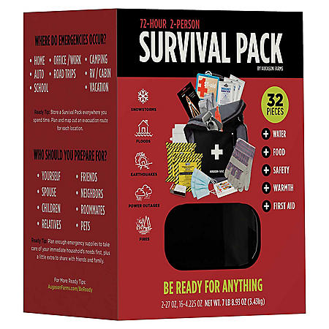
2-Per 72 hr. Backpack Kit DTC | $50.00 | https://www.samsclub.com/p/72-hr-survival-pack-augason-farms-32-pcs/prod25150244?xid=plp_product_2

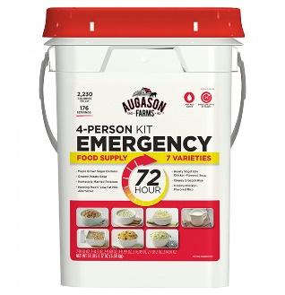
AF 4 Person 72hr Emergency 4G Kit | $48.10 | https://www.augasonfarms.com/index.php?route=product/search&search=5-20100

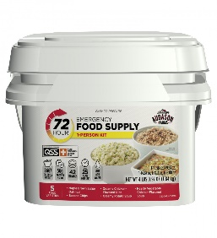
AF 72hr 1G Kit | $18.30 | https://www.augasonfarms.com/index.php?route=product/search&search=5-32200

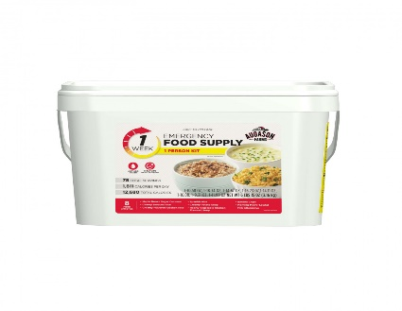
AF 1 Week 1 Person 2G Pail Kit | $28.69 | https://www.augasonfarms.com/index.php?route=product/search&search=5-32201

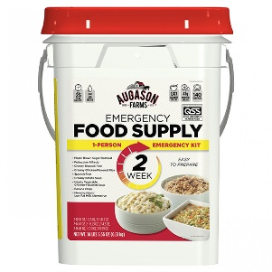
AF 2 Week 4G Kit | $46.73 | https://www.augasonfarms.com/index.php?route=product/search&search=5-32202

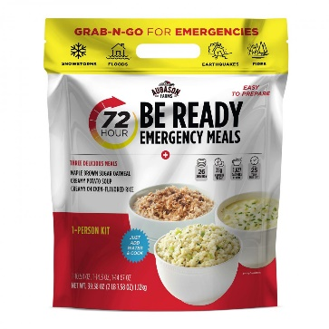
AF 72-Hour Emergency Food Kit Pouch | $7.77 | https://www.augasonfarms.com/index.php?route=product/search&search=5-06110

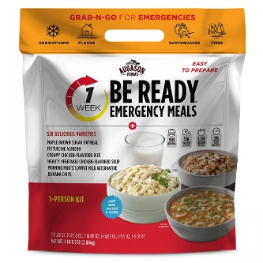
AF Be Ready 1-Week Pouch | $14.33 | https://www.augasonfarms.com/index.php?route=product/search&search=5-26673

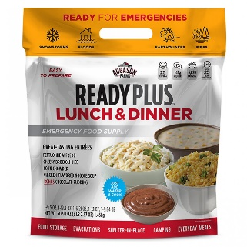
AF Be Ready Lunch/Dinner Variety Pouch | $11.60 | https://www.augasonfarms.com/index.php?route=product/search&search=5-26674

