Three Lasagna Recipes Your Family Will Love This Week

Homemade lasagna is comfort. It’s a pasta lover’s dream and family favorite with layers of noodles, melty cheese, and savory sauce. Whether you add meat or keep it vegetarian, this classic dish comes together with minimal effort but packs in the flavor, leaving the whole family happy. When faced with a busy weeknight or when dinner for four turns into dinner for 10, lasagna is a go-to.

With Food Club, Family Meal Favorites Start Here
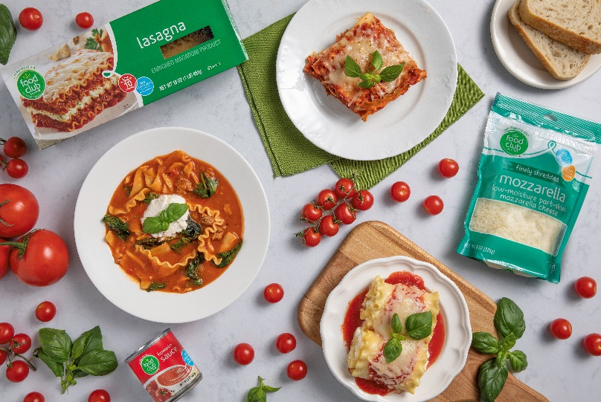
Basic, flavorful ingredients are at the core of any recipe. And when it comes to lasagna, this is especially true. The best part is that you can use three simple ingredients to transform lasagna into three distinct, easy, and delicious meals that the whole family will love.
Here’s what you need:
- Food Club Lasagna Pasta
- Food Club Tomato Sauce
- Food Club Shredded Mozzarella Cheese

Recipe #1: Simple Oven Baked Lasagna
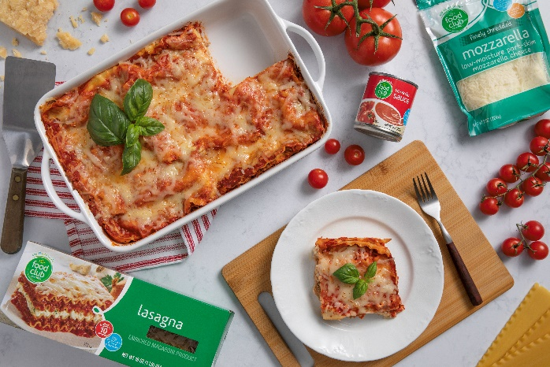
Start with your base of Food Club lasagna noodles, mozzarella cheese, and tomato sauce, and add in some Italian sausage. These layers easily come together and bake in the oven into a delicious casserole that will feed a crowd. Of course, this is the traditional version, but it’s a simple recipe that can be customized to satisfy your family’s preferences. Vegetarian? Make a simple swap with your favorite veggies. Love chicken? Substitute ground chicken for sausage. There are no limitations and this meal is simple enough for any busy weeknight dinner. You can even make it in advance and re-heat any leftovers make for an easy and delicious second meal.

Click HERE for the full recipe.

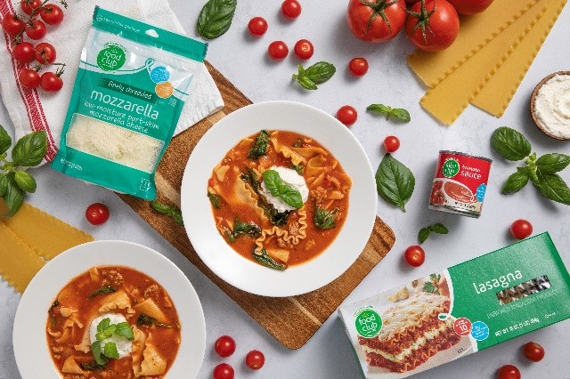
Recipe #2: Slow Cooker Lasagna Soup
What could be better than two comfort dishes in one? With Food Club lasagna noodles, mozzarella cheese, and tomato sauce as the foundation, soup and lasagna come together in this super simple one-pot meal that packs in the flavor. Simply, cook it low and slow in a crockpot and let all the flavors meld together into a meal that the whole family will love. Ladle rich, tomato-based broth with pieces of lasagna noodles, veggies, and Italian sausage into your favorite bowl and top with a mixture of mozzarella and ricotta cheeses.

Click HERE for the full recipe.

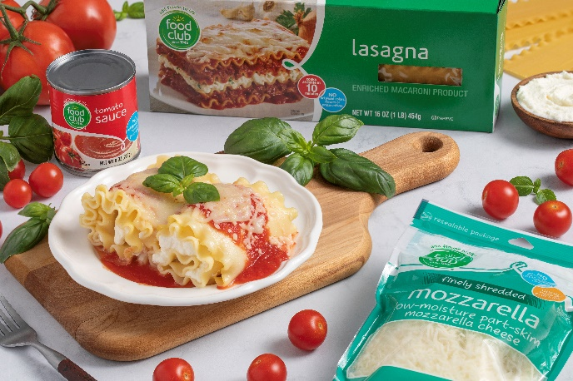
Recipe #3: Air Fryer Lasagna Roll Ups
Transform Food Club lasagna noodles, mozzarella cheese, and tomato sauce layered lasagna into an easy-to-serve family-friendly meal that’s cooked to perfection in the air fryer. Lasagna noodles make the perfect vehicle for rolling up traditional cheese filling. Love meat? Add cooked and seasoned ground beef, turkey, or Italian sausage for an even more filling meal. The big flavors and simplicity of making lasagna roll ups will satisfy any weeknight meal. And the leftovers make the perfect quick, re-heatable lunch.

Click HERE for the full recipe.

